

Lab # 3

**Web Engineering Fall 2020**



|  |  |
| --- | --- |
| Instructor | Sir Bakht Muhammad |
| Student Name | Sheryar Baloch |
| CMSID | 333432 |
| Department | Computer Science |
| Semester | 8th |

**Introduction to Cascading Style**

# Lesson Set 3

**sheets**

|  |  |  |
| --- | --- | --- |
| **Purpose** | 1. | To get a basic awareness of CSS |
|  | 2. | To understand CSS and why we are using it. |
|  | 3. | To add some styles to the existing web pages |
| **Procedure** | 1. | Students should read the Pre-lab Reading assignment before coming to lab. |
|  | 2.  3. | Students should complete the Pre-lab Writing assignment before coming to the lab.  In the lab, students should complete Labs 3.1 through 3.4 in sequence. |
|  | 4. | Your instructor will give further instructions on grading and completing the lab.  Students should complete the set of lab tasks before the next lab and get |
|  |  | them checked by their lab instructor. |

|  |  |  |  |
| --- | --- | --- | --- |
| **Contents** | **Pre-requisites** | **Completion Time** | **Page Number** |
| Pre-lab Reading Assignment | - | 20 min | 3 |
| Pre-lab Writing Assignment | Pre-lab Reading | 10 min | 4 |
| **Lab 3** | | | |
| **Lab 3.1**  CSS | Pre-lab reading | 30 min | 5 |
| **Lab 3.2**  Lab Tasks | Awareness with CSS | - | 9 |

**PRE-LAB READING ASSIGNMENT**

**What is CSS** CSS stands for Cascading Style Sheets, CSS is the language for describing the presentation of Web pages, including colors, layout, and fonts. It allows one to adapt the presentation to different types of devices, such as large screens, small screens, or printers. CSS is

independent of HTML and can be used with any XML-based markup language. The separation of HTML from CSS makes it easier to maintain sites, share style sheets across pages, and tailor pages to different environments. This is referred to as the separation of structure (or: content) from presentation. For example in previous the lab task was look like this.

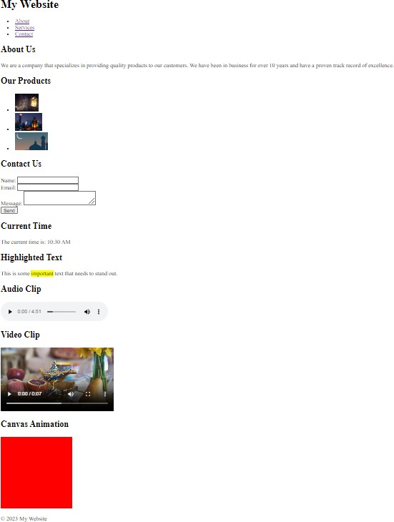

With the help of CSS, we will try to make it look better as shown below:

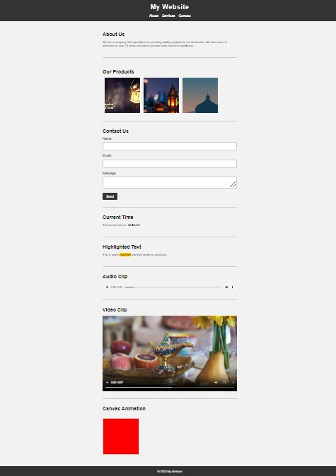

**Ways to Add CSS** There are three different ways to add CSS to a web page:

**External CSS:** In this method, CSS is written in a separate file with a

.css extension and then linked to the HTML document using the <link> tag in the <head> section. For example:

*<head>*

*<link rel="stylesheet" href="style.css">*

*</head>*

**Internal CSS:** In this method, CSS is written in the <style> tag in the

<head> section of the HTML document. For example:

*<head>*

*<style> h1 {*

*color: red;*

*}*

*</style>*

*</head>*

**Inline CSS:** In this method, CSS is applied directly to an HTML element using the "style" attribute. For example:

*<h1 style="color: red;">Hello World!</h1>*

**Starting with CSS** In CSS, there are different ways to write and apply styles to HTML elements, but some general rules and best practices include:

CSS styles are written in a separate file with a .css extension or can be added directly into an HTML file using the <style> tag.

To start writing CSS for a web page, you can first identify the different HTML elements that you want to style and group them by adding a class or an ID attribute to them. For example:

*<h1 class="page-title">My Website</h1>*

*<nav id="main-menu">*

*<ul>*

*<li><a href="#about">About</a></li>*

*<li><a href="#services">Services</a></li>*

*<li><a href="#contact">Contact</a></li>*

*</ul>*

*</nav>*

You can then target these elements in your CSS by using selectors.

Selectors can be the element name, the class name, the ID name, or a combination of these. For example:

*/* Targets all h1 elements */ h1 {*

*font-size: 2em; color: #333;*

*}*

*/* Targets the element with the class "page-title" */*

*.page-title {*

*font-weight: bold;*

*text-transform: uppercase;*

*}*

*/* Targets the element with the ID "main-menu" */ #main-menu {*

*background-color: #eee;*

*}*

*/* Targets the <a> tags inside an element with the class "button" */*

*.button a {*

*color: white;*

*text-decoration: none; background-color: blue;*

*}*

* CSS styles are usually written in a format of "property: value;", where the property is what you want to change about the element (e.g., color, font-size, margin), and the value is what you want to set it to (e.g., red, 16px, 10px auto).
* CSS styles can also be organized into different sections or blocks and can be cascaded or overridden based on their specificity and order of application. It's good practice to organize your CSS styles in a way that is easy to read, understand, and maintain.

**PRELAB WRITING ASSIGNMENT**

**Fill in the blanks** 1. CSS stands for Cascading Style Sheets and is used for

HTML web pages.

1. The three main ways to apply CSS to an HTML document are through , , or styles.
2. CSS selectors are used to target HTML elements and apply styles based on , , or .
3. The in CSS describes how elements are structured with content, padding, borders, and margins.
4. CSS and can be used to create dynamic effects and animations on web pages.

# Lab 3.2 Lab Tasks

1. Modify the Lab 2 project and CSS to that project. The project should cover the following:
   1. **Basic syntax and selectors:** Cover the basic syntax of CSS, including selectors, properties, and values. Students should use CSS to change the appearance of elements on a web page.
   2. **Box model:** Cover the box model, which describes how elements are displayed on a web page. Students should use CSS to control the size, padding, and margins of elements.
   3. **Layouts:** Cover CSS layouts, including how to use floats and positioning to create different types of layouts. Students should create responsive layouts that work well on different screen sizes.
   4. **Typography:** Cover how to use CSS to control the appearance of text on a web page, including font families, sizes, colors, and styles. Students should use CSS to create readable and visually appealing text.
   5. **Responsive design:** Cover how to use CSS to create responsive designs that

work well on different screen sizes. Students should use media queries and other CSS techniques to create designs that adapt to different devices.

* 1. **Advanced topics:** Cover advanced CSS topics, such as animations, transitions, and transformations. Students should use these techniques to create visually

interesting and engaging web pages.

**NOTE**: Animation as hover the element or others, transition to navigation to the page

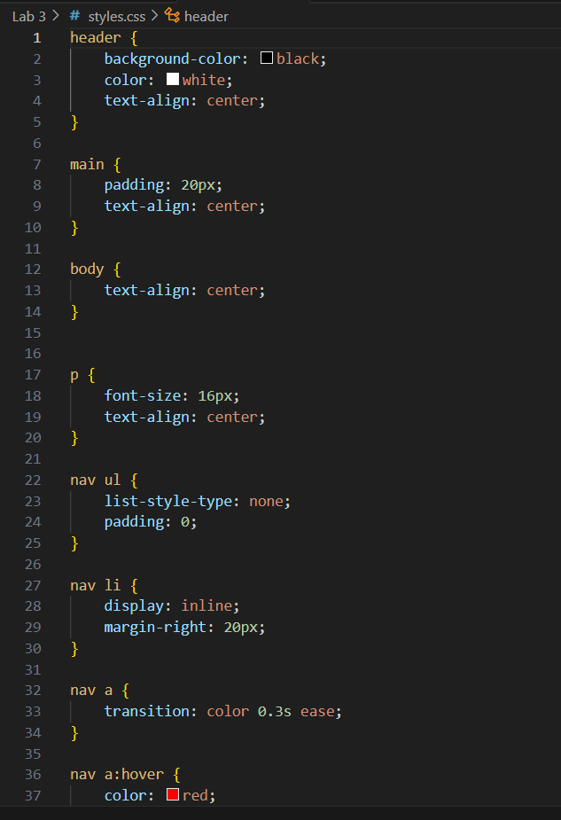

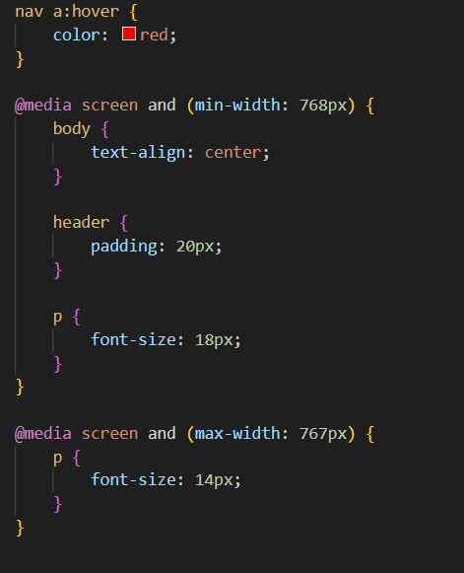

**Output:**



**Github Link:** sheryarbaloch123.github.io